FOUNDATION FOR VIRTUAL AND AUGMENTED REALITY SYSTEMS
Lecture45
Lec-45: System Implementation
Hello and welcome to the NPTEL MOOCs course on Foundations for Virtual and Augmented Reality Systems. We are going to start a new part, a new topic on this system implementation overall broad topic. So, we will be continuing with the system implementation broadly. However, we are going to talk about something different in this part of the lecture. So, earlier we learned about
the remaining two stages in the earlier parts of this lecture, of this design prototype evaluate cycle. More specifically, we talked about the prototyping idea and the quick evaluation of those prototype ideas. Also, we discussed how we implemented the Majuli VR Tour in brief. Now in this lecture, we are going to talk about another important stage for any interactive system development, that is empirical evaluation. Just to put matters into perspective, let us quickly recollect the overall interactive system development lifecycle.
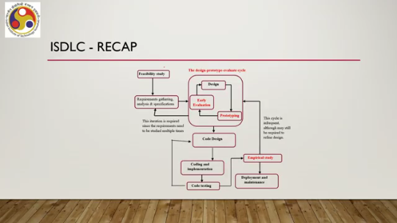
We have the feasibility study stage, then the requirement gathering analysis and specification stage. This one we discussed earlier. Then we talked about the design prototype evaluate cycle where we primarily focus on interface and interaction design. So, the design stage we talked about earlier, the prototyping and evaluation these two stages we talked about in the previous parts of this lecture. As I mentioned before, we are not going to talk about these three stages namely code design, coding, and code testing.
These are any standard; these follow the standard methodologies that are already there for any system development. Our remaining interest is in empirical study, which essentially deals with evaluating the usability of the developed system with end users. After the code testing stage, we get a system that is executable. However, it does not say anything about a usable system. Whereas through empirical study or empirical evaluation, we are going to ascertain whether the system is usable or not.
And this stage is going to be discussed in this part of the lecture. So, the stage is known in several forms. Empirical study or usability study or empirical research and so on. So, we will be using the term empirical study. Previously, we talked about how to evaluate the usability of our designs, whatever designs we have come up with.
Now, if you can recollect, those evaluations, that is the quick prototype evaluations, were primarily done by are primarily done by experts. Now, here the term experts essentially refers to those expert designers who are well accustomed to the domain of the problem. Of course, we have also talked about user evaluation in a very brief sense, but that was not a very rigorous or robust type of evaluation. So, everything that we talked about was on a very limited scale.
Be it expert evaluation or user evaluation. That limited scale, of course, is good enough for quickly identifying some major usability issues that may be there in our design. Now, the idea of the design-prototype-evaluate lifecycle is to have a quick design, get a quick prototype, and get a quick evaluation of the prototype so that we identify the issues. Then we rectify the design again, rectify the prototype, perform another quick evaluation, and so on, until the number of problems reduces.
Now, in order to make it quick, to make everything quick, what we do is basically employ a limited number of evaluators and do the evaluation only on prototypes. This is, of course, good for early evaluation. However, it cannot give us a conclusive result about the overall usability of the end system. For that, we need to evaluate our whole implemented system with a larger number of users, preferably, to get a conclusive idea on usability.
Now, in order to get that conclusive idea on usability, what we need is a fully implemented system. It cannot be done on prototypes. The second thing is, in order to do that, what we generally need to do is perform a controlled experiment to collect user behavioral data and also to analyze that data, to come to a conclusion. So, two things are important: one is a fully implemented system, and second is a controlled
experiment. So, these two we must have access to or we must execute to be able to perform or to be able to conclude about the usability of the overall system. Now, when we talk about such controlled experiments, generally that is referred to as empirical research or an empirical study or a user study. However, in our context, it is specifically related to usability evaluation.
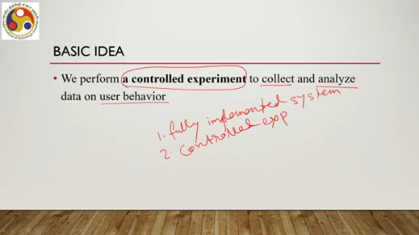
So, we can also use that setup or that process and call it a usability study. Now, when we perform this controlled experiment to collect data, analyze data to come to a There are broadly four stages in that overall process of empirical research or empirical study. So what are those four stages? First is the identification of research questions.
Now the term here is research questions. So essentially we are dealing with a process called empirical research questions. And in order to perform the research, we need to first start with some questions for which we seek the answers. The formulation of those questions or identification of those questions is the first stage of the whole process. The second thing is the determination of variables.
This is another important thing. Once the questions are formulated, we need to identify the variables. There are several types of variables. Unless we do that, we will not be able to design and execute a controlled experiment. So, identification of variables or determination of variables is the second stage of the process.
Third is design of experiment. This is the most important part. Of course, the other two are also important, but this one is the crux of the process where we design an experiment to collect the data. So, design of experiment essentially means design of the experiment as well as collection of data by execution of the experimental design.
And finally, the fourth stage is analysis of the data. This is also a rigorous process. To come to a definite conclusion about the overall usability aspects of the system, we need to properly, scientifically, and objectively analyze the data so that the conclusion is reliable and that is also very important. So, identification of research questions.
The first stage is determination of variables based on the research questions, the second stage is design and execution of the experiment, and finally analysis of the data to come to a conclusion. In order to understand this process or these stages, let us proceed with an example. To keep things simpler, we have chosen a simple GUI type example so that it is easier to comprehend the idea. Suppose we have developed a new text entry interface that is an interface through which a user can provide text input or create textual documents.
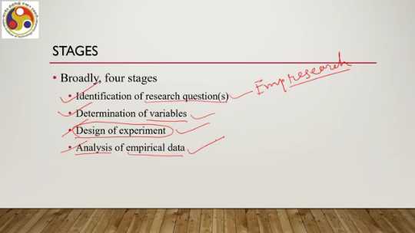
So this is nothing but a graphical user interface. to provide or input text to the system. Now, what we want is the system is developed; we have implemented the system. Now, what we want is to perform an empirical study through which we will be collecting empirical data. to measure the usability of the interface.
So, here it may be noted that the system has been fully implemented and now our objective is to set up the experiment, execute the experiment, collect data for analysis, and that process is empirical study. So, with respect to this example, let us Try to understand stage 1, that is research questions. What is a research question?
How do we formulate it? What is a good question? What is a bad question? These types of concepts, let us try to understand with respect to this example. So, we want to conduct an experiment.
For that, we need to frame a question. Through the experiment, we will try to find the answer to this question. So, let us start with a question: Is the new interface technique good? So, let us term this as research question 1 or RQ 1. So, if we frame such a question, what will happen?
Now, based on these questions, we collect data and analyze data to answer this question. So, observations or empirical data collection needs to be performed based on this question. So, in order to do that, what do we do? We present the interface to a user and ask the user to judge its quality.
And we repeat this process a few times for several users, say five users. Of course, later on we will see what is a good number of users to engage in an empirical study for a suitable conclusion. So, we repeat the process a few times and complete our experiment. So, what kind of observations can we make?
So, this is the experimental log or the recorded observations based on the research questions that we have formulated. So, there are 5 users: user 1 said good. So, our question was: is the interface good? So, user 1 said good, user 2 said poor, user 3 said not very good but not very bad either. User 4 said good and user 5 said very bad.
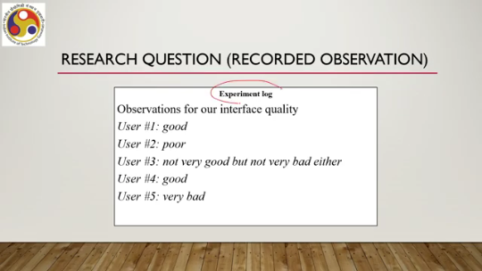
Now, if we get such responses from the users, what can we conclude and is that conclusion definitive? As we can observe from the logged observations, opinion is equally divided: two said good, two said poor or very bad, and one in between neither good nor bad. So, it is quite possible that these types of observations we can end up with if we frame such a question and ask users for their feedback. So, from these types of observations or from these feedbacks, We are not likely to get answers to RQ1.
Is it good? We cannot conclude. So, there is something problematic with our research question. So, let us try to change it and have another question. Let us call it RQ2.

Is our text input interface better than the text input interface provided by, say, MS Word? This is another experiment log. Again, 5 users. User 1 says no, MS Word has many features. User 2 says yes, it is a clean interface.
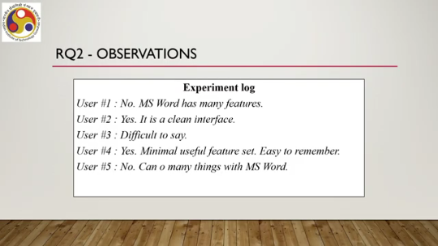
User 3 says difficult to say. User 4 says yes, minimal useful feature set, easy to remember. User 5 says no, can do. Should be read as: can do many things with MS Word. Here we ask the users to compare the proposed system with another existing system and then users revealed more.
However, are these observations any better to take us to a definitive conclusion about the quality of the proposed system? So, from these observations we can conclude the following. When asked to compare, users give somewhat more concrete feedback as compared to feedback based on a standalone system. Now, better to some means more features and to others means fewer features. That is very interesting to observe.
Some may still be confused, says user 3. So that still also does not take us any closer to a definitive conclusion about the proposed system. Now, let us reframe the question with RQ3, research question 3. Does the new interface let me enter text faster than MS Word?

This is a completely different type of formulation as you can note by comparing it with RQ1 and RQ2, the previous two formulations of the research questions. Now, in this case, what changes? We do not just ask for feedback which may be vague and subject to interpretation as we have just seen. Now, what we are asking for, what we are trying to collect is we give them some task that is input a text and ask for their feedback which is less prone to subjective interpretations. So now let us see what kind of feedback we can expect from the users.
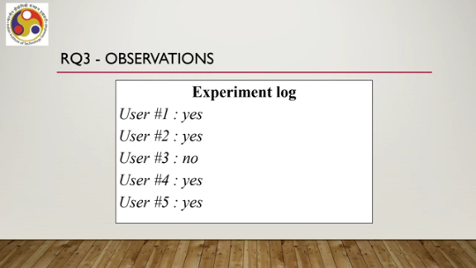
So here, unlike the previous cases, users could give more unambiguous answers such as user 1 yes, user 2 yes, user 3 no, user 4 yes, user 5 yes. This is so because the question is much more unambiguous. Users have to compare the two and then tell whether one is faster over the other in comparison to the other. However, although there is more clarity in the feedback, the feedback itself may still be problematic. It may still be difficult to come to a definite conclusion.
As you can see, two may say yes, two may say no. and so on and so forth. So, it is always a problem when we depend on subjective feedback. The good part here is that because of the nature of the research question, we can actually collect objective data such as text entry speed rather than relying on subjective feedback to come to a definite conclusion.
In order to collect objective data, what we need to do is we need to set up an experiment, collect the actual text entry speeds and then compare to come to a conclusion. So, their subjective feedback is not required. We can give them the same task that is the same text to input, then record text entry speed number of characters entered per minute or CPM. We can compare CPM values and give objective conclusions rather than relying on subjective feedback on the idea of faster.
Of course, we can collect feedback from them on whether one is faster than others based on their understanding of the speed, but that is not necessarily the case. We can also collect objective measures. By following this process, we can give them some task, the same task to all, record text entry speed through some logging mechanism, and compare the speeds to determine which one is faster. Now, since here we are not relying only on user feedback, instead we can actually come to a conclusion based on something that is objective, not subjective to users' interpretation. The R3 question, number R3, we can call a testable question, or sometimes it is called a hypothesis, and R1 also R2, R1 and R2, as non-testable.
So, in the case of R1 or R2, we cannot have objective measures; it is purely based on users' interpretation, subjective interpretation, and their feedback, whereas for R3 we can actually collect objective information such as text entry speed, irrespective of what the user thinks about the speed or what the user's interpretation is about the term 'faster.' So, such types of questions, if we frame them, are called testable questions. We can test them objectively. They are often called hypotheses.
Other questions, where we cannot directly test them objectively, are called non-testable questions. Now, there are So, when we are given the task of framing research questions, it may happen that we come up with testable questions, or it may so happen that we come up with non-testable questions. So, which one is good, which one is bad, which one should we follow? These are issues that we need to resolve. Now, there is always a trade-off.
We cannot frame questions based on generalized concept For example, RQ1, whether something is good, that is a very generic concept. What is good? It is not clear, it is ambiguous. So, generally we cannot frame questions or we should not frame questions based on generalized concepts because that may lead to untestable questions.
So, when we are framing untestable questions, then the result is, The feedback that we get from users is very much prone to subjective interpretation and then from there drawing a definitive conclusion which is scientific and reliable is not possible generally. Instead, we should go for testable questions from which we can draw reliable, definite conclusions. However, if we go for more specific questions such as RQ3, we might get testable questions but we may not get true answers. So, RQ3 says that one interface is faster than another.
However, it does not say whether something is better than another. Now, faster and better are different concepts. So, they are certainly not the same. So, we may frame testable questions but we may not get generalized answers with such testable questions.
So, to balance the trade-off, what we need to do is we need to frame multiple testable questions. And from the conclusion of each of those questions, we can sum up the conclusions and come to a conclusion about the generalized or untestable question. Say RQ4 is the error rate within one hour of use less in our interface as compared to MS Word. RQ5 is the number of features supported in our interface sufficient to perform common tasks. For this, we need to collect feedback on a rating scale of 1 to 5 where 1 indicates not at all and 5 indicates totally agree.
Even RQ6 is Can you remember the features easily on a rating scale of 1 to 5 where 1 indicates not at all and 5 indicates totally agree? See RQ 3, 4, 5, 6 or research questions 3, 4, 5, 6. These four we can collect objective data because we are either using a rating scale or some metric to directly measure the values, say text entry rate or error rate. Using these, we can collect objective data, we can conclude about the question, and when we combine the answers to all these questions,
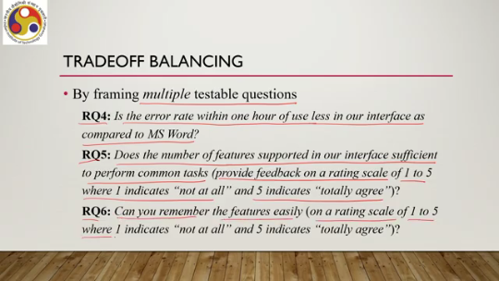
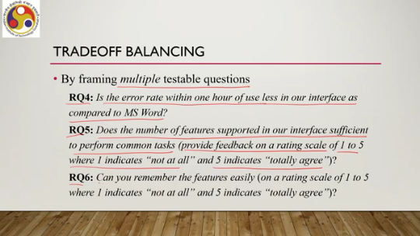
then we can come to a definite conclusion about the overall goodness of the interface, that is the generalized version of the question which is untestable. So, to balance the trade-off, what we need to do is frame multiple research questions covering different multiple testable research questions covering different aspects of the system. So, that from their conclusions we can draw a conclusion about the broader untestable research questions. So, that is stage 1 of the empirical study: framing of research questions. The idea is to frame research questions, multiple research questions that are testable, and from their conclusions draw definitive conclusions about untestable broader generalized research questions.
Now, when we use the term 'testable', that means we can conduct a study and collect objective data for conclusion, for drawing conclusions, whereas when we use the term 'untestable question', that means based on untestable questions we cannot set up any controlled experiment and collect objective data. So, to collect objective data we need to set up testable questions and based on the conclusion of testable questions we can draw conclusions for untestable questions. Both are important and in this way we can manage them. Now, let us move to the second stage, that is variable identification.
Let us reconsider research question 3. We have considered two values for the interface variable: our design and the MS Word. Now, we used to observe the text entry speed for each: our design and MS Word. So, how we arrived at these interfaces: we assigned some values to the variable, we controlled its value.
So, the variable here is interface. Interface is a variable where we assign the values: our interface versus MS Word interface. So, two values we assigned, we controlled its values. Such variables which are controlled are known as independent variables. Sometimes, or in fact, many times we use the term 'factors' to denote
these variables. So, we can use the term either independent variable or factors, and the values assigned to those factors we can call levels. So, the values assigned to variables are also known as levels of the variable independent variable or factor. In our example, the factor is the interface and levels; there are two levels: one is our design and the other one is MS Word. Now, the factors combined with their levels give us the test conditions for the experiment.
So, based on these factors and levels, we can decide or design our experiment. For example, observe text entry speed for a given text with our design and also with MS Word. So, we can have two such test conditions, for the factors and levels in our example because there are two levels. So, for each level, we can set up that experiment: observe text entry speed first for our system and secondly for the existing system, that is, MS Word.
Now, in RQ3, there is also another variable, the text entry rate TER, based on which we are drawing a conclusion whether it is faster or not. Now, the value of the variable depends on the interface, more specifically the levels of the interface. So, therefore, it is called the dependent variable. So, it depends on the interface. So, we have independent variable or factor having levels, and depending on the levels, we get some values for the dependent variable.
So, in our case, the dependent variable is the text entry rate. That is the second stage. So, just to recollect, we are talking about an empirical study. So in summary, what we can say is that we are talking about empirical evaluation, which we can term as empirical study, empirical research, or usability research. The term empirical means observation in the real world of real users.
And this is done at the end when the system is fully implemented. to get some idea of the overall usability of the system. There are four stages. So we started talking about those stages. The first stage is the identification of research questions.
We saw that the identification of research questions is not easy. So essentially, we need answers for broader, generalizable questions which are untestable, for which conducting an experiment and collecting objective data for a definitive conclusion is not possible. However, we can overcome this by framing multiple testable research questions for each of which we can collect objective data, come to a definite conclusion, and then we can combine these conclusions for all the testable questions to come to a conclusion about the untestable questions. That is the research question framing.
Second thing is variables. So, to design an experiment, we need to identify the variables in the testable questions. Two types of variables are of importance here. There are other variables also. I will provide reference material from which you can get more details on these concepts.
But the two most important variable types are dependent variables and independent variables. We have independent variables or factors which can take up levels or values, and then we have dependent variables which depend on the factors and levels. So, these are the first two stages of the empirical research or empirical study process. Two more stages remain which we will discuss in the next part of the lecture. So, I hope you could follow the topics and understand the concepts.
Looking forward to meet you in the next part of the lecture. Till then, thank you, goodbye, and happy learning.

